Data Modeling – Place Rush Order

# Conceptual Data Model

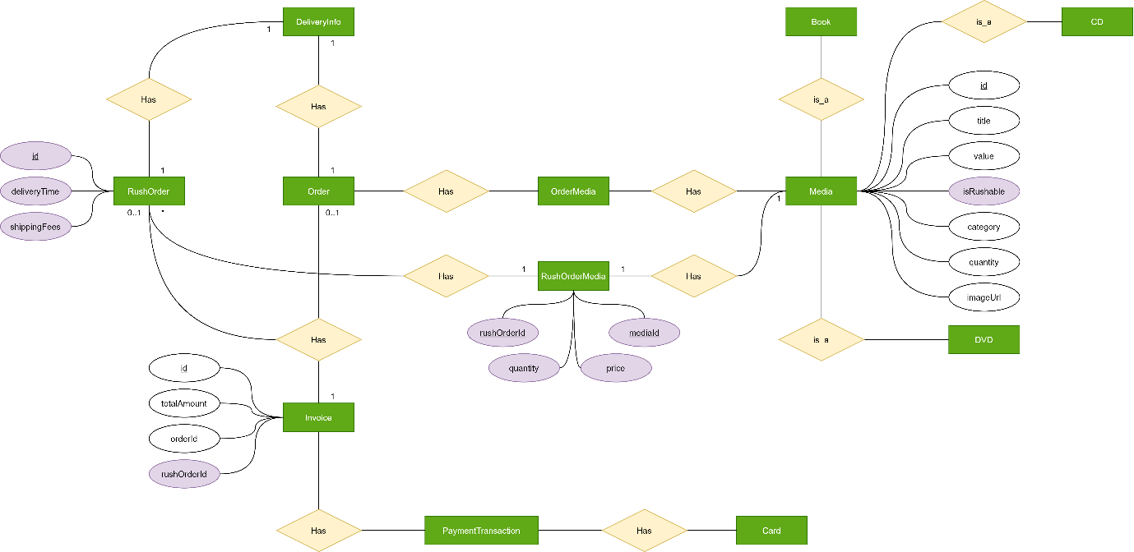

# Database Design

## Logical Data Model

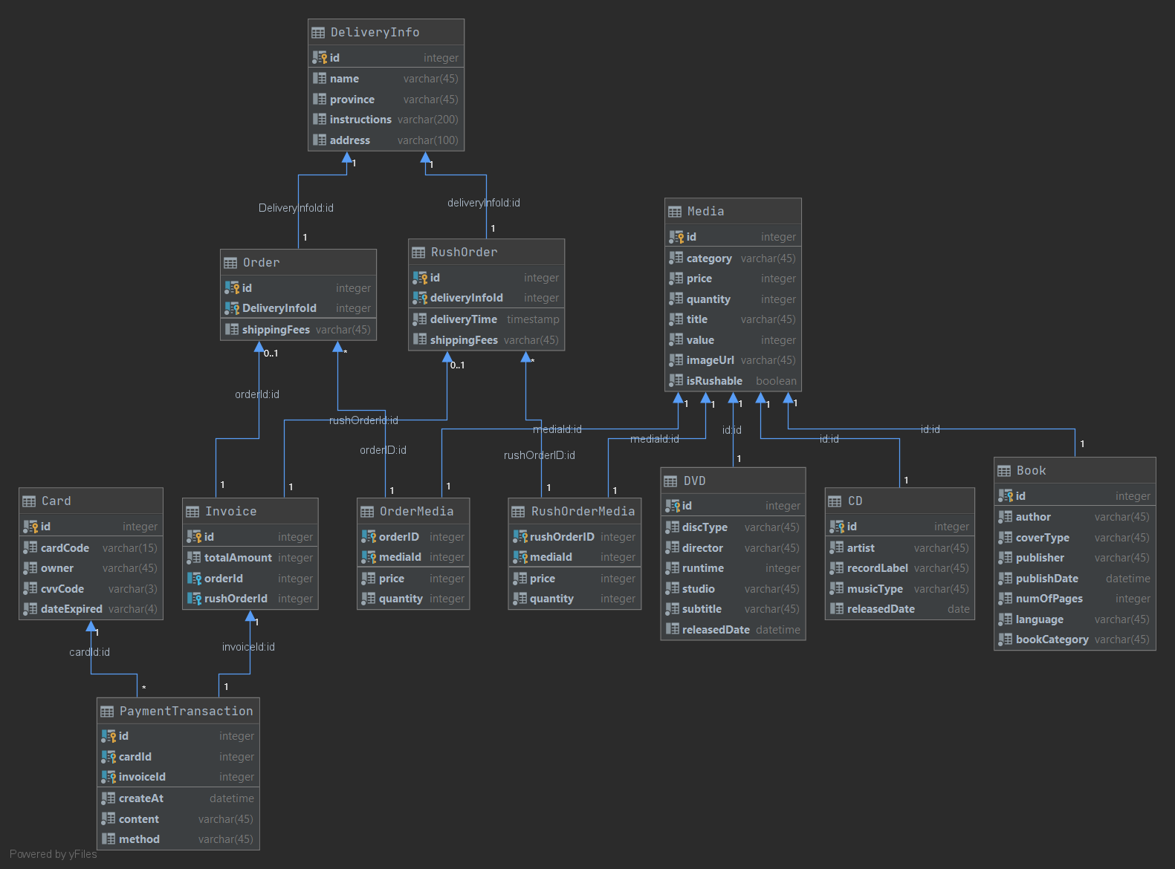

## Physical Data Model

**Media**

|  |  |  |  |  |  |  |
| --- | --- | --- | --- | --- | --- | --- |
| # | PK | FK | Column Name | Data type | Mandatory | Description |
| 1. | x |  | id | Integer | Yes | ID, auto increment |
| 2. |  |  | category | VARCHAR(45) | Yes | Media type |
| 3. |  |  | price | Integer | Yes | Current price |
| 4. |  |  | quantity | Integer | Yes | Number of products |
| 5. |  |  | title | VARCHAR(45) | Yes | Product name |
| 6. |  |  | value | Integer | Yes | Value of product |
| 7. |  |  | imageUrl | VARCHAR(45) | Yes | Product image path |
| 8. |  |  | isRushable | Boolean | Yes | Rush delivery support status |

**RushOrderMedia**

|  |  |  |  |  |  |  |
| --- | --- | --- | --- | --- | --- | --- |
| # | PK | FK | Column Name | Data type | Mandatory | Description |
| 1. | x | x | rushOrderId | Integer | Yes | Id of rush order it belongs |
| 2. | x | x | mediaId | Integer | Yes | Id of media |
| 3. |  |  | price | Integer | Yes | Price at placed time |
| 4. |  |  | quantity | Integer | Yes | Number of bought items |

**Invoice**

|  |  |  |  |  |  |  |
| --- | --- | --- | --- | --- | --- | --- |
| # | PK | FK | Column Name | Data type | Mandatory | Description |
| 1. | x | x | id | Integer | Yes | auto increment |
| 2. |  |  | totalAmount | Integer | Yes | total charge |
| 3. |  | x | orderId | Integer | No | normal order id |
| 4. |  | x | rushOrderId | Integer | No | rush order id |

**RushOrder**

|  |  |  |  |  |  |  |
| --- | --- | --- | --- | --- | --- | --- |
| # | PK | FK | Column Name | Data type | Mandatory | Description |
| 1. | x |  | id | Integer | Yes | auto increment |
| 2. |  |  | deliveryTime | Timestamp | Yes | scheduled delivery time |
| 3. |  |  | shippingFees | Integer | Yes | shipping fee for rush delivery |
| 4. |  | x | deliveryInfoId | Integer | Yes | delivery info id |

**Scripts:**

BEGIN;  
CREATE TABLE "Media"  
(  
 "id" INTEGER PRIMARY KEY AUTOINCREMENT NOT NULL,  
 "category" VARCHAR(45) NOT NULL,  
 "price" INTEGER NOT NULL,  
 "quantity" INTEGER NOT NULL,  
 "title" VARCHAR(45) NOT NULL,  
 "value" INTEGER NOT NULL,  
 "imageUrl" VARCHAR(45) NOT NULL,  
 "isRushable" BOOLEAN NOT NULL  
);  
CREATE TABLE "DeliveryInfo"  
(  
 "id" INTEGER PRIMARY KEY AUTOINCREMENT NOT NULL,  
 "name" VARCHAR(45),  
 "province" VARCHAR(45),  
 "instructions" VARCHAR(200),  
 "address" VARCHAR(100)  
);  
CREATE TABLE "RushOrder"  
(  
 "id" INTEGER NOT NULL,  
 "deliveryTime" TIMESTAMP NOT NULL,  
 "shippingFees" VARCHAR(45),  
 "deliveryInfoId" INTEGER NOT NULL,  
 PRIMARY KEY ("id", "deliveryInfoId"),  
 CONSTRAINT "fk_RushOrder_DeliveryInfo1"  
 FOREIGN KEY ("deliveryInfoId")  
 REFERENCES "DeliveryInfo" ("id")  
);  
CREATE TABLE "RushOrderMedia"  
(  
 "rushOrderID" INTEGER NOT NULL,  
 "mediaId" INTEGER NOT NULL,  
 "price" INTEGER NOT NULL,  
 "quantity" INTEGER NOT NULL,  
 PRIMARY KEY ("rushOrderID", "mediaId"),  
 CONSTRAINT "fk_rushOrdermedia_rushOrder"  
 FOREIGN KEY ("rushOrderID")  
 REFERENCES "RushOrder" ("id"),  
 CONSTRAINT "fk_RushOrderMedia_Media1"  
 FOREIGN KEY ("mediaId")  
 REFERENCES "Media" ("id")  
);  
CREATE INDEX "RushOrderMedia.fk_rushOrdermedia_rushOrder_idx" ON "RushOrderMedia" ("rushOrderID");  
CREATE INDEX "RushOrderMedia.fk_RushOrderMedia_Media1_idx" ON "RushOrderMedia" ("mediaId");  
CREATE TABLE "Invoice"  
(  
 "id" INTEGER PRIMARY KEY NOT NULL,  
 "totalAmount" INTEGER NOT NULL,  
 "orderId" INTEGER,  
 "rushOrderId" INTEGER,  
 CONSTRAINT "fk_Invoice_Order1"  
 FOREIGN KEY ("orderId")  
 REFERENCES "Order" ("id"),  
 CONSTRAINT "fk_Invoice_RushOrder1"  
 FOREIGN KEY ("rushOrderId")  
 REFERENCES "RushOrder" ("id")  
  
);  
CREATE INDEX "Invoice.fk_Invoice_Order1_idx" ON "Invoice" ("orderId");  
CREATE INDEX "Invoice.fk_Invoice_RushOrder1_idx" ON "Invoice" ("rushOrderId");  
COMMIT;